YES, I want to train martial arts (boxing/MMA/judo) with De Grondleggers for the academic year 2018-2019.
(You are required to have SCB sports rights if you wish to train with us!)

First name: ............................... Last name............................ Initials: ..................
Date of birth (dd-mm-yyyy): ( _ _ - _ _ - _ _ _ _ ) Nationality: .........................................
E-mail (we use your.name@wur.nl if available): ....................................................................

I am a WUR BSc / WUR MSc / STOAS / 1st year graduate / PhD* student
*Strikethrough non-applicable. A limited number of PhD students is allowed to join us.
(Student) registration number: .....................................................................................
WBA number (barcode on your WURcard, see image below): ( _ _ _ _ _ _ _ _ _ _ _ _ )
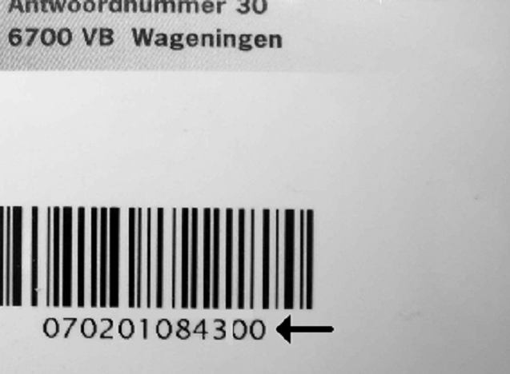
Your subscription is not valid without this number!
This number is only valid after you purchased
sports rights.

Contribution fee for 2018-2019: €30 allows you to practice any art we have to offer without limitations.

Visit www.grondleggers.wur.nl to read our house rules. Our website should also provide answers to any further questions you might have. If you still have questions, do not hesitate to contact us via wsbv.grondleggers@wur.nl !

Payment: mandate for one off collections – S€PA

Name creditor : De Grondleggers
Address creditor : Bornsesteeg 2
Postal code creditor : 6708 PE Place of residence creditor : Wageningen
Country creditor : The Netherlands Creditor Identifier : NL93ZZZ401239080000
Mandate reference : Contribution fee 2018-2019

By signing this mandate form, you authorize De Grondleggers to send one off collection instruction to your bank to debit your account for € 30,00 and your bank to debit your account on a one-off basis in accordance with the instruction from De Grondleggers. If you do not agree with the debit, you can arrange for its refund. Please contact your bank within eight weeks from the date on which your account was debited. Ask your bank for the conditions.

Name : ................................................................................................................
Address : .................................................................................................................
Postal code : ( _ _ _ _ )( _ _ ) Place of residence : .................................................
Country : ......................................................................................................................................
Account number [IBAN] : ( _ _ _ _ )( _ _ _ _ )( _ _ _ _ )( _ _ _ _ )( _ _ )
Bank Identification code [BIC]* :..................................…
* Not an obligatory field for Dutch accountnumber

Place and date : ......................................................... Signature

